How to Root Sony Smartwatch 3

This is a guide to root your Sony Smartwatch 3

Warning, following this guide will void your warranty

These instructions assume you have already:
- downgraded your watch to build number LCA43; and
- installed NFC on your watch

If you have not please refer to:
- James Thurlow’s pinned post 3rd October 2016
- Steven Peel’s pdf in Files - How to install NFC on Sony Smartwatch 3 modified by Sean Stringer 26th October 2016

These instructions are based on:
https://forum.xda-developers.com/smartwatch-3/development/lwx49k-rooting-easy-t3107501

- Download Wear-SuperSU-v2.46.zip
http://forum.xda-developers.com/attachment.php?attachmentid=3342605&d=1433157678
and save it in the same adb folder you used when you installed NFC on your watch

- Open Android Wear on your phone
Select the cog wheel icon top right
Select your watch from the list under Device settings
Select FORGET WATCH at the bottom of the screen

- Go to Settings on your watch and select Factory reset

- When your watch has restarted:
- Select your preferred language
- Connect to a power source

- Your watch will now ask to be paired with your phone – do not do this now

- To get to the Settings menu press the button on the side of the watch

- Go to About and tap the Build number until it says “You are now a developer”

- Go to Developer options in the Settings menu and enable ADB debugging
Confirm when asked ADB debugging Are you sure?; and
Select “OK” or “Always from this computer”

- Type cmd in the Windows Start Menu search box

- Right click Command Prompt and select Run as administrator
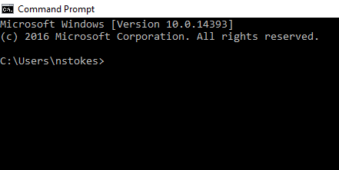

- Type “cd\adb” (assuming c:\adb is the folder where you have saved all the files for the previous NFC installation
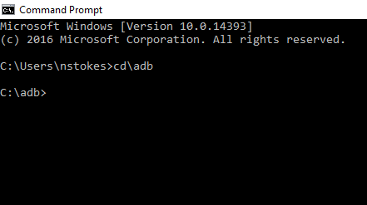

- Type “adb devices”
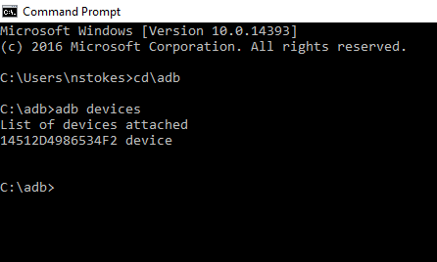
If your watch is not listed or listed as unauthorised you will check the drivers on your PC and change them (please refer to the document “How to install NFC on Sony Smartwatch 3”)

- Type “adb reboot bootloader”
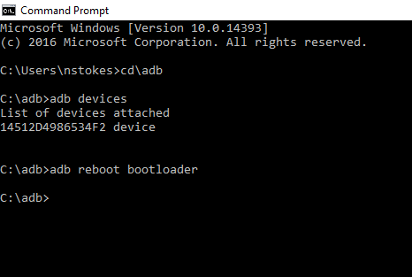
Your watch screen should say “Running Fastboot”

- Check device manager on your PC
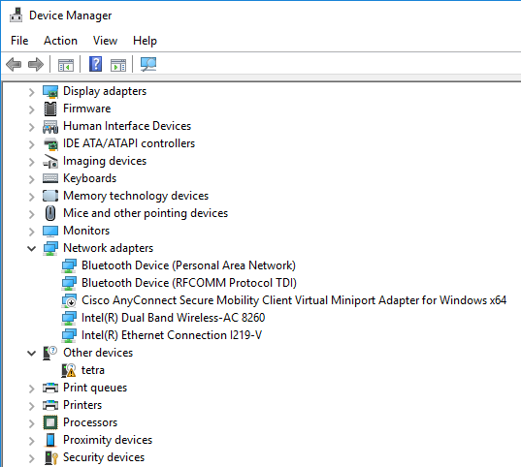
If your watch is listed as “tetra” you will need to change the driver
When you have done this your watch should now be listed as Android ADB Interface
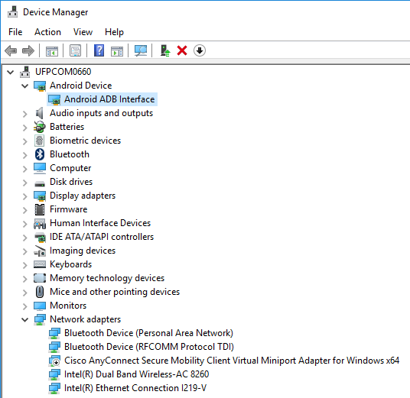

- Type “fastboot boot twrpnew.img”
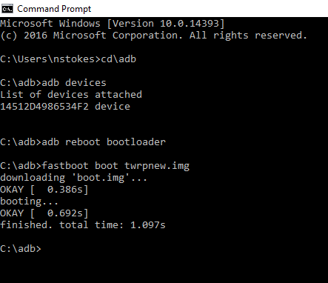

- Type “adb push Wear-SuperSU-v2.46.zip /sdcard/”
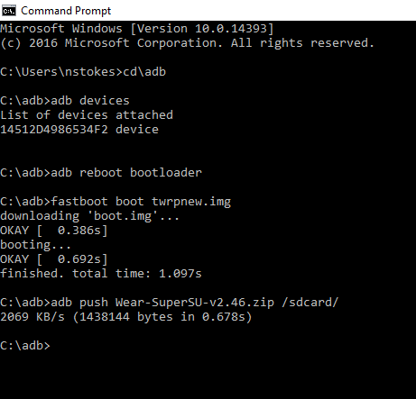
Your watch screen should say “Swipe to Unlock”
Swipe right
Select “Install”
Scroll down and select Wear-SuperSU-v2.46.zip
Your watch screen will say “Swipe to Confirm Flash”
Swipe right
The file will install
Select “Reboot System”

- Your watch should now be rooted

- If you want to disable/uninstall/delete apps on your watch, go to Play Store on your phone and install the Root Essentials app

- When your watch has restarted:
- Select your preferred language
- Connect to a power source

- Your watch will now ask to be paired with your phone
Now you can pair your watch with your phone

- During the Syncing process the Root Essentials app will be installed on your watch
Using the Root Essentials app on your watch you can disable/uninstall/delete apps on your watch
Please refer to Matthias Neu’s guide:
https://drive.google.com/file/d/0B4SEho0Ogq8iaElDdkNrZ2NuTmc/view

